A simple guide on the shiny app

Before we can use the shiny app please download the whole folder “FIT3164S2”

All material needed for running the shiny interface is in this folder.

(Also: If R and Rstudio is not downloaded on the computer, please download them here: <https://cran.r-project.org/bin/windows/base/> (R)

here: <https://rstudio.com/products/rstudio/download/> (R-studio) )

Once both programs are downloaded, open up R-studio and on the top left, under the “File” tab navigate to “Open File”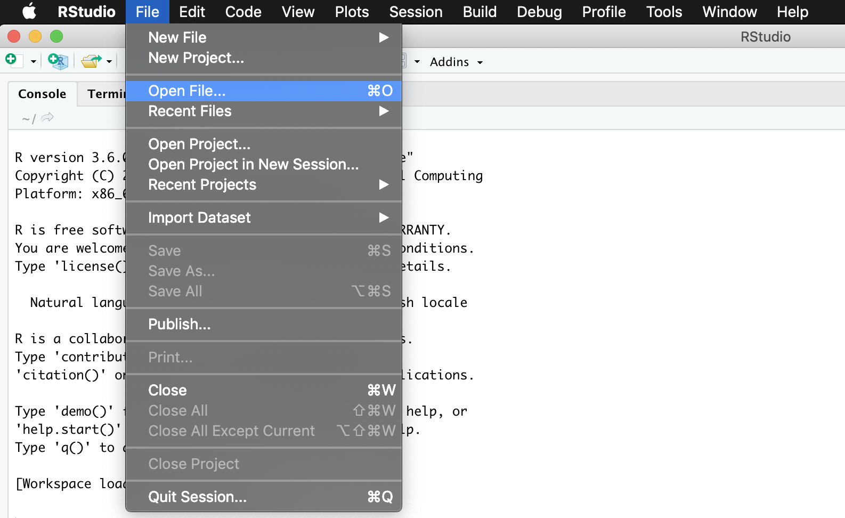

Then navigate to the “Shiny” folder inside “FIT3164S2” which you have downloaded, and inside the “Shiny” folder, choose “main.R”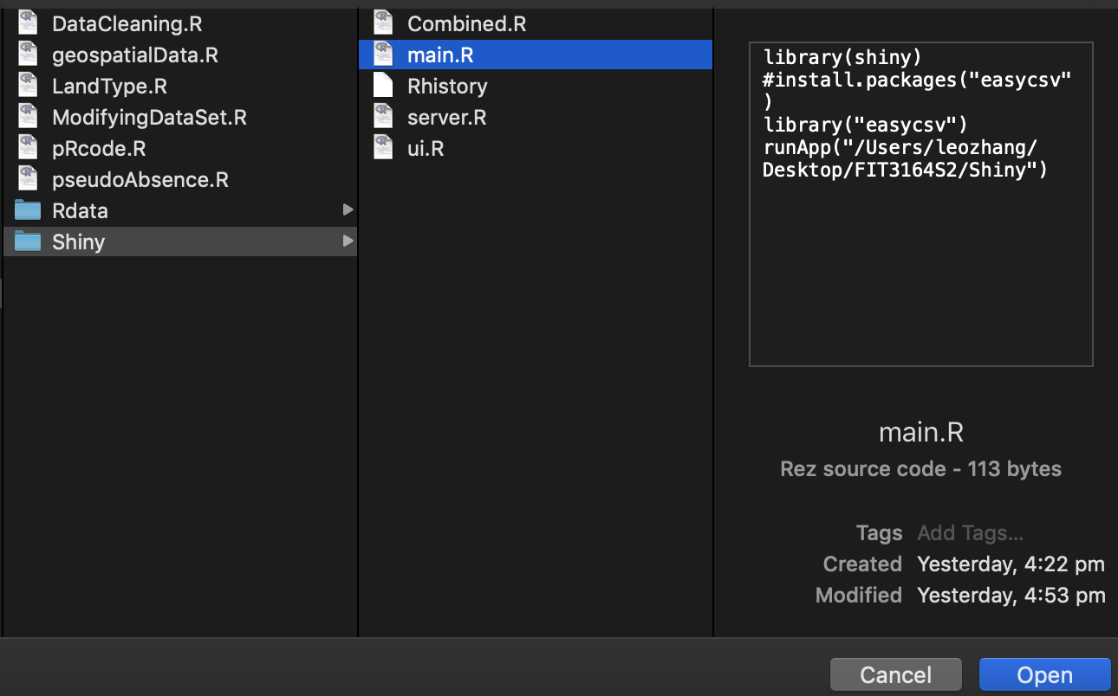

Once opened you should see something like this: 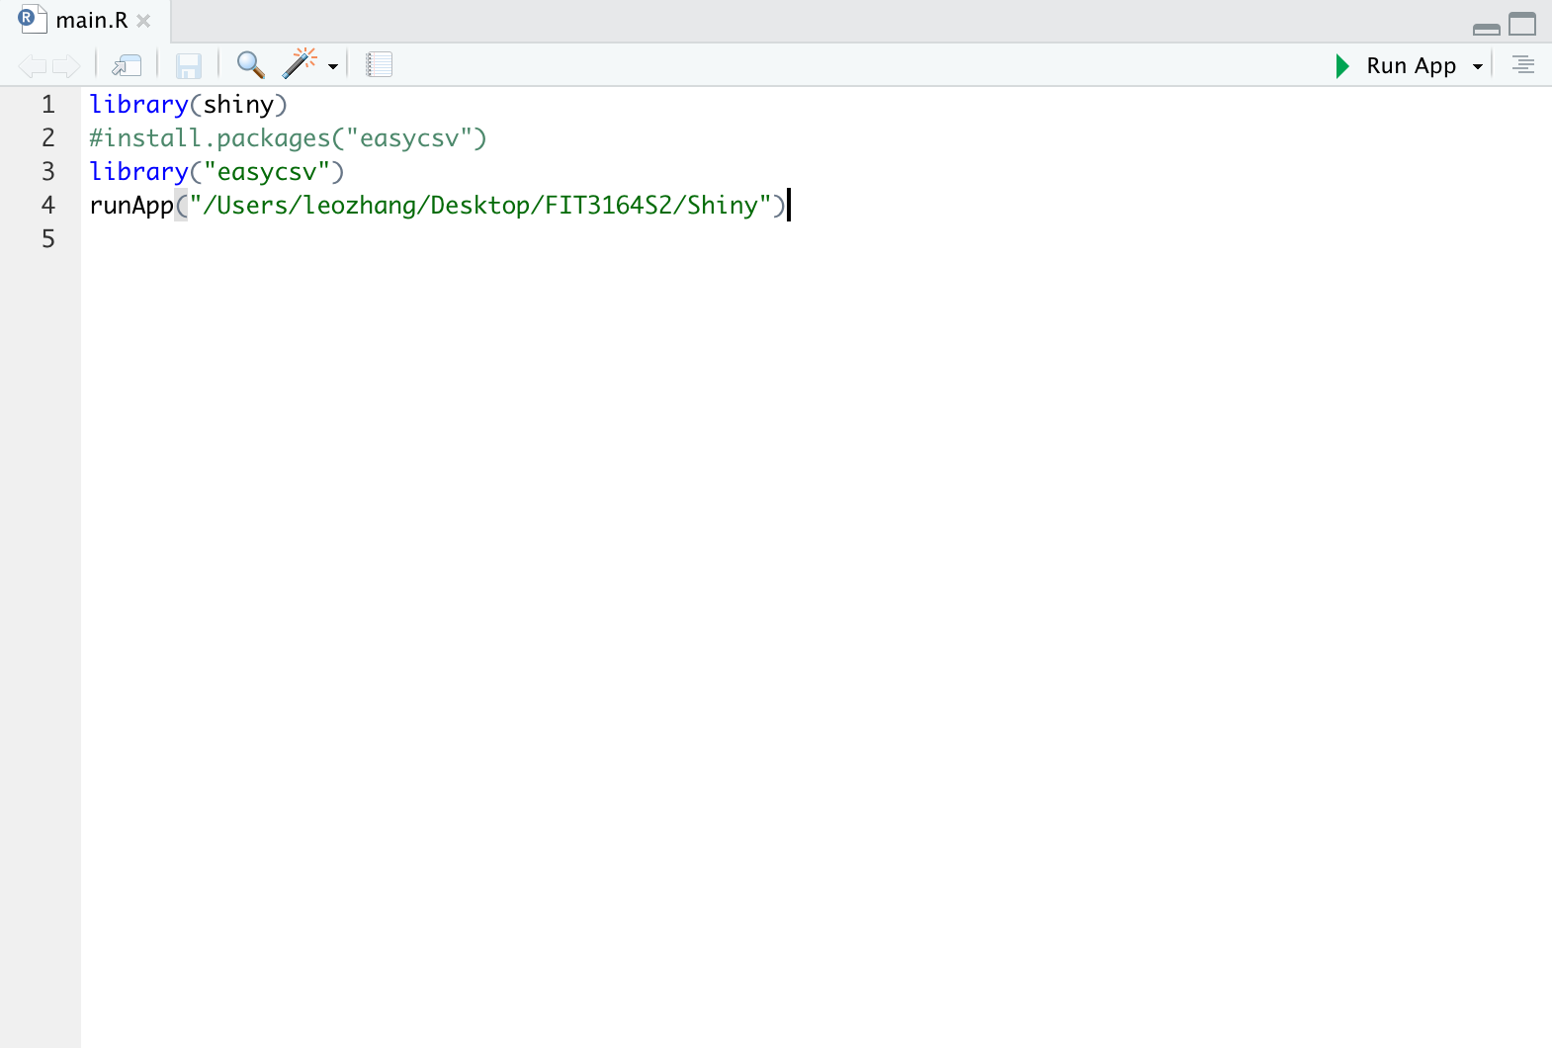

Now, press run app on the top right of the R script. (Red Cycle)

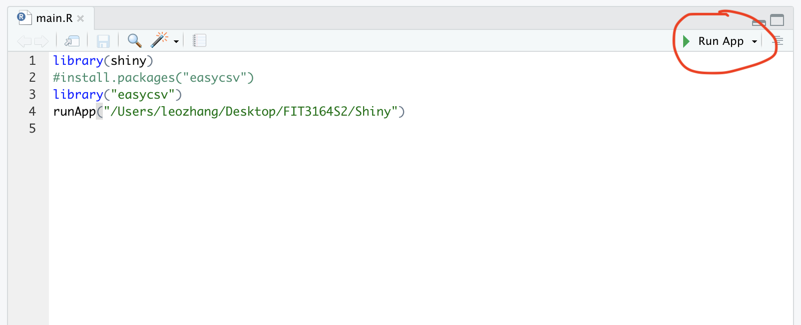

It should look something like the following:

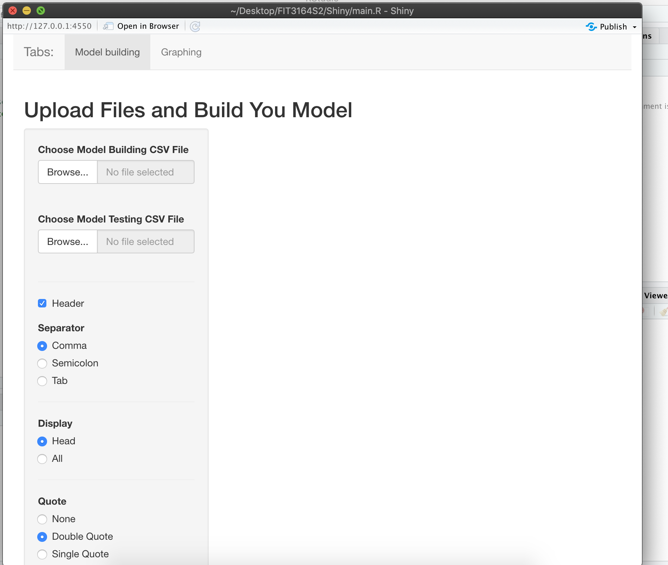

There are two menus

One is the Upload menu and the other is the Graphing menu

We are on the Upload menu right now and we can only do Graphing after we have our predicted data.

Now there’s two places for us to upload files:

The black circle is for us to upload the data that we have already modified and thus will be used for model training.

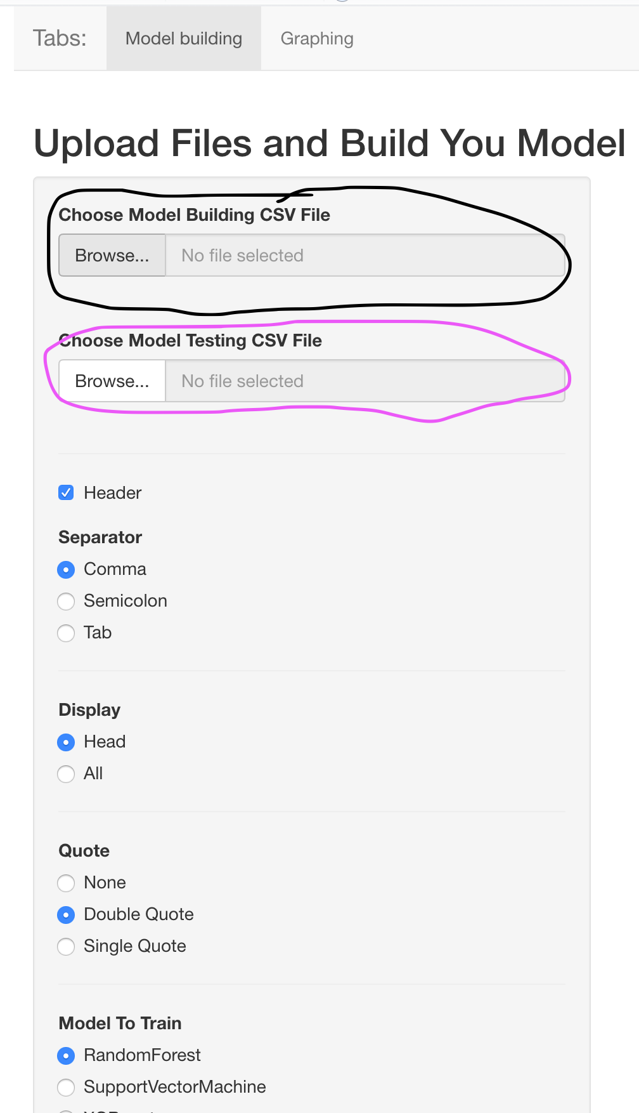

The purple place is for us to upload the new data that we want to classify/predict.

----------------------------------------------------------------------------------------------------------------

For the model training data, Navigate to “FIT3164S2” -> “Rdata” -> “Finalpseudo.csv”

And press open.

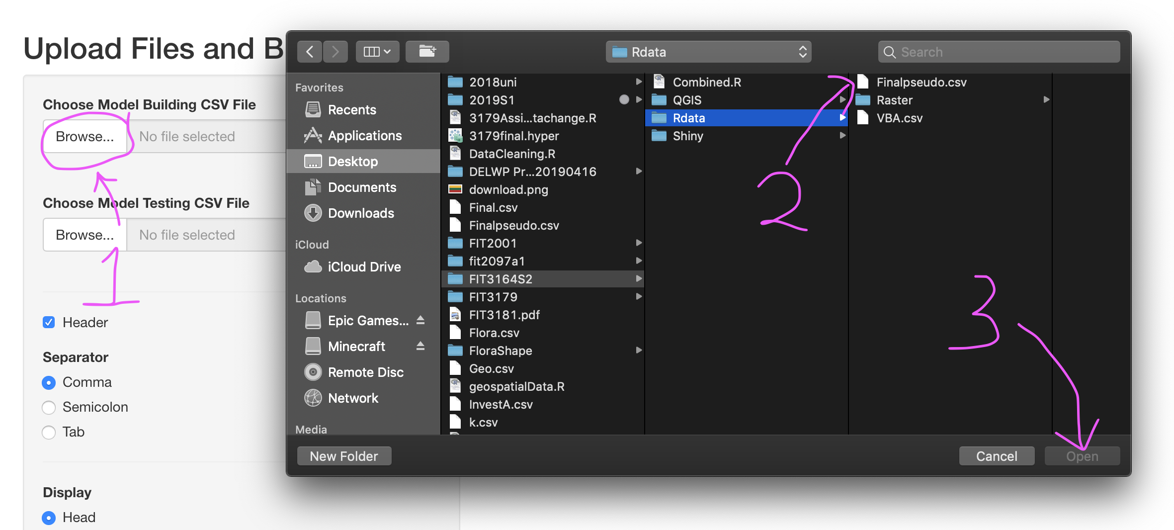

For testing purposes, we will use the original VBA data as our data for prediction/classification. (The VBA data is in the same directory)

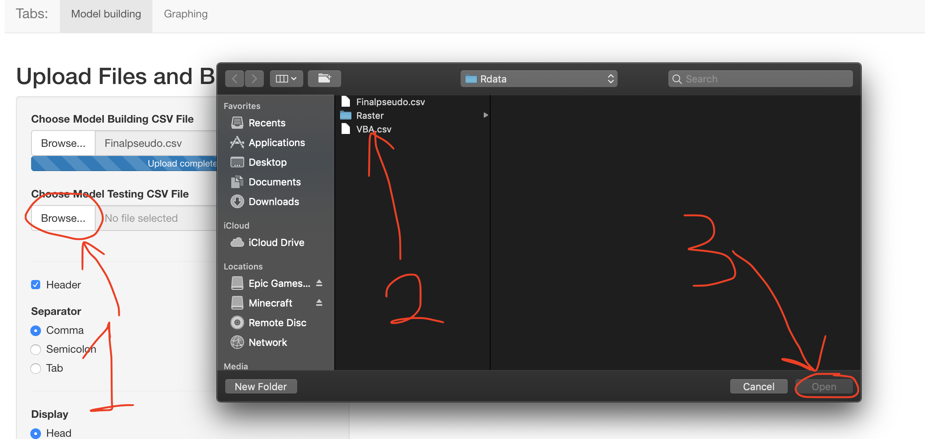

Once both files are loaded, it should look something like this:

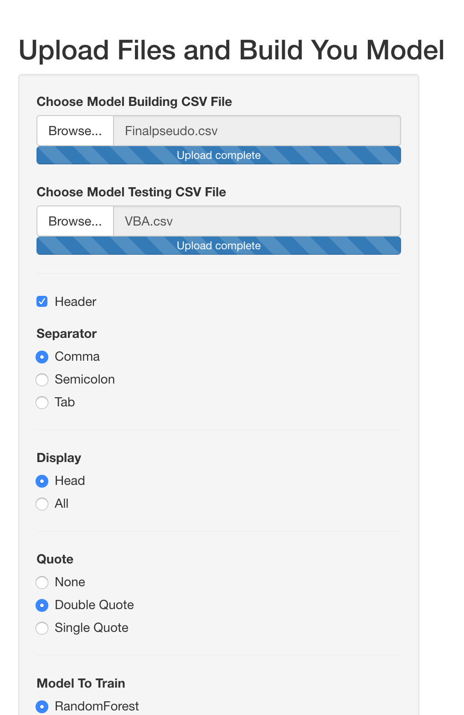

----------------------------------------------------------------------------------------------------------------

Now we are ready to Train the models, clean the data and also predict the data.

----------------------------------------------------------------------------------------------------------------

To train the model:

Choose a Model that you want to train (Blue circle)

Then

Simply press the Train Model button (Red circle) and you should see something as the following

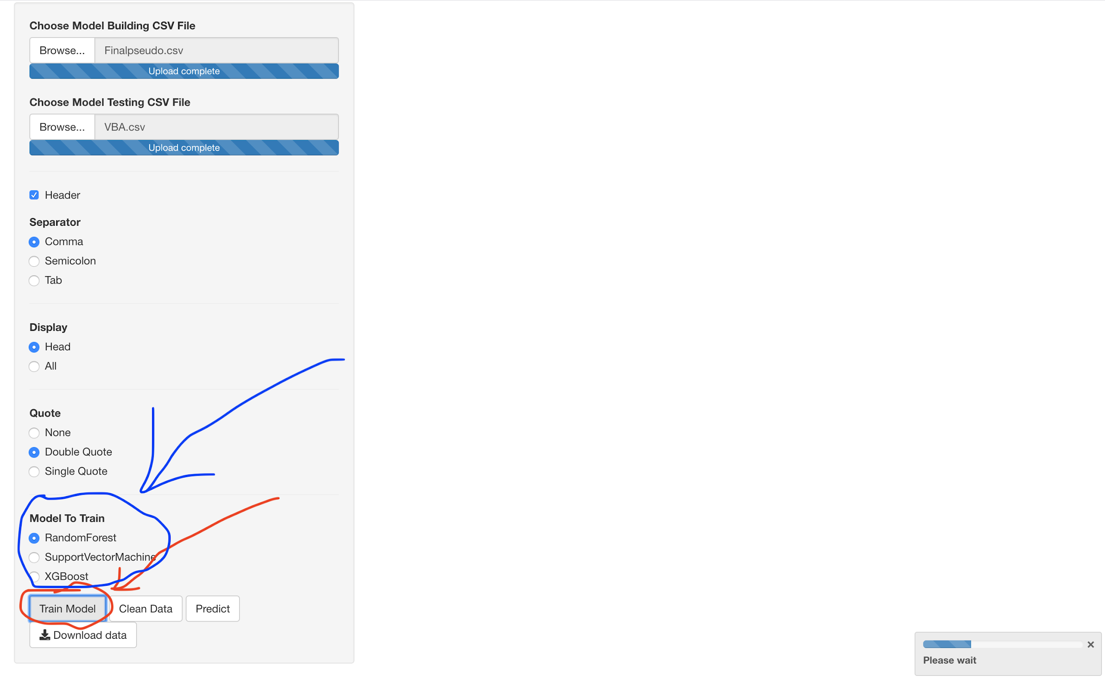

This will take a bit so please be patient…………

After it is done, it should look something like this:

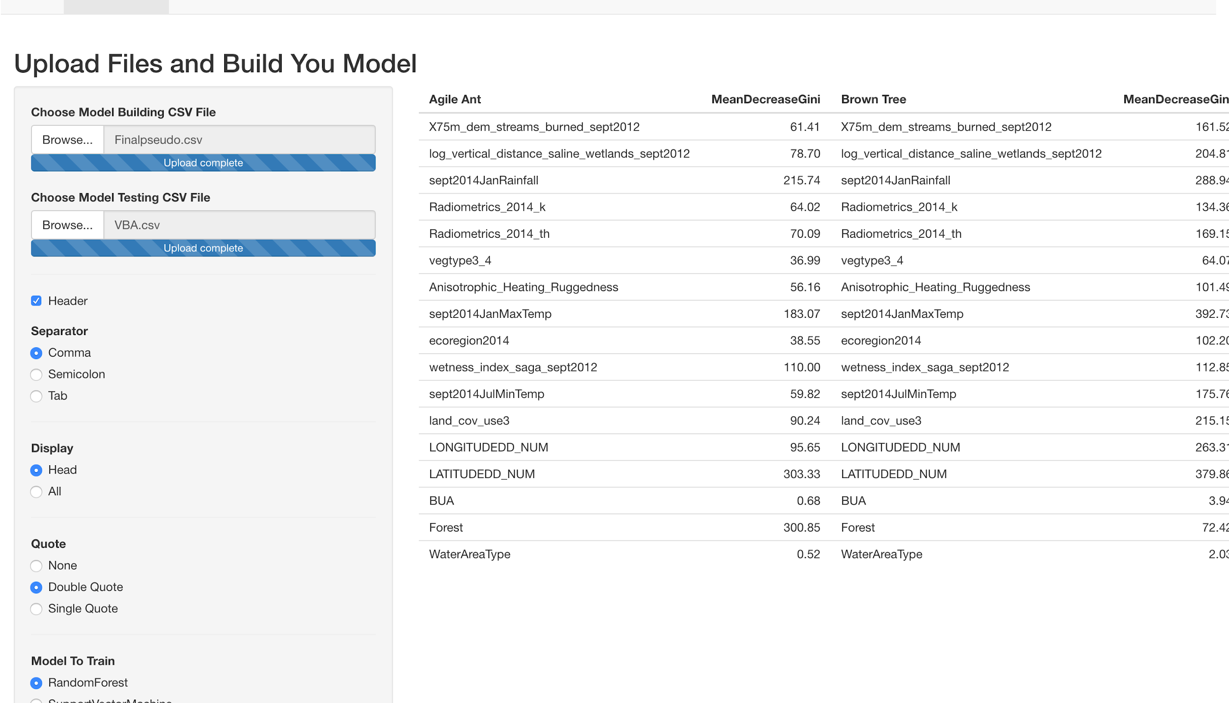

A table has appeared on the screen, the table actually shows the models attribute importance for each species, you can scroll to the right to see more:

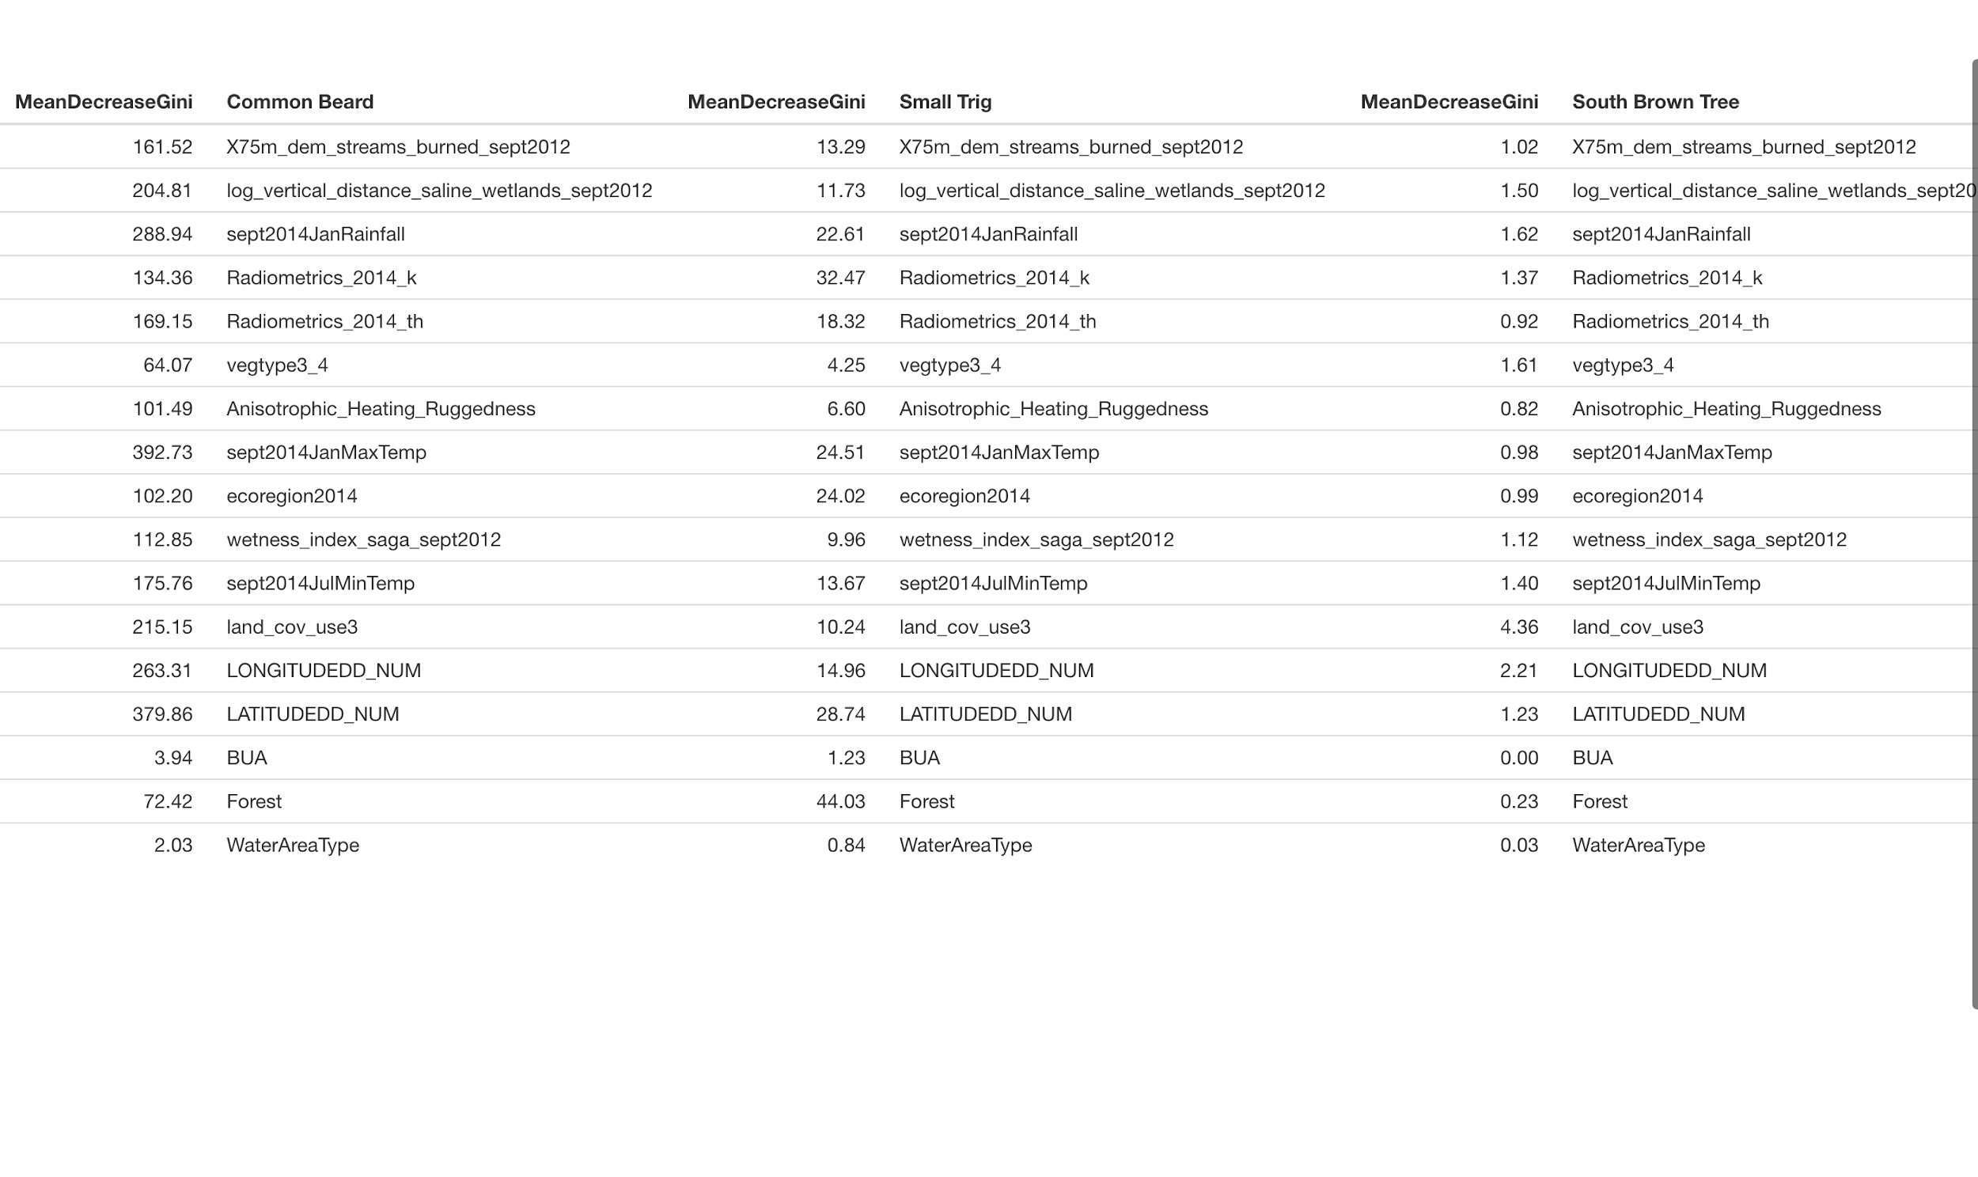

If you want to choose other models, just choose another model type and press train model again and it will automatically train that type of model for you.

Unfortunately, the model attribute importance for the SVM model type does not work, even though the models are trained, there will be no attribute importance shown.

----------------------------------------------------------------------------------------------------------------

Data Cleaning

----------------------------------------------------------------------------------------------------------------

Scroll back down to the button area and click on the Clean Data button

Once you have pressed the button, a window will pop out:

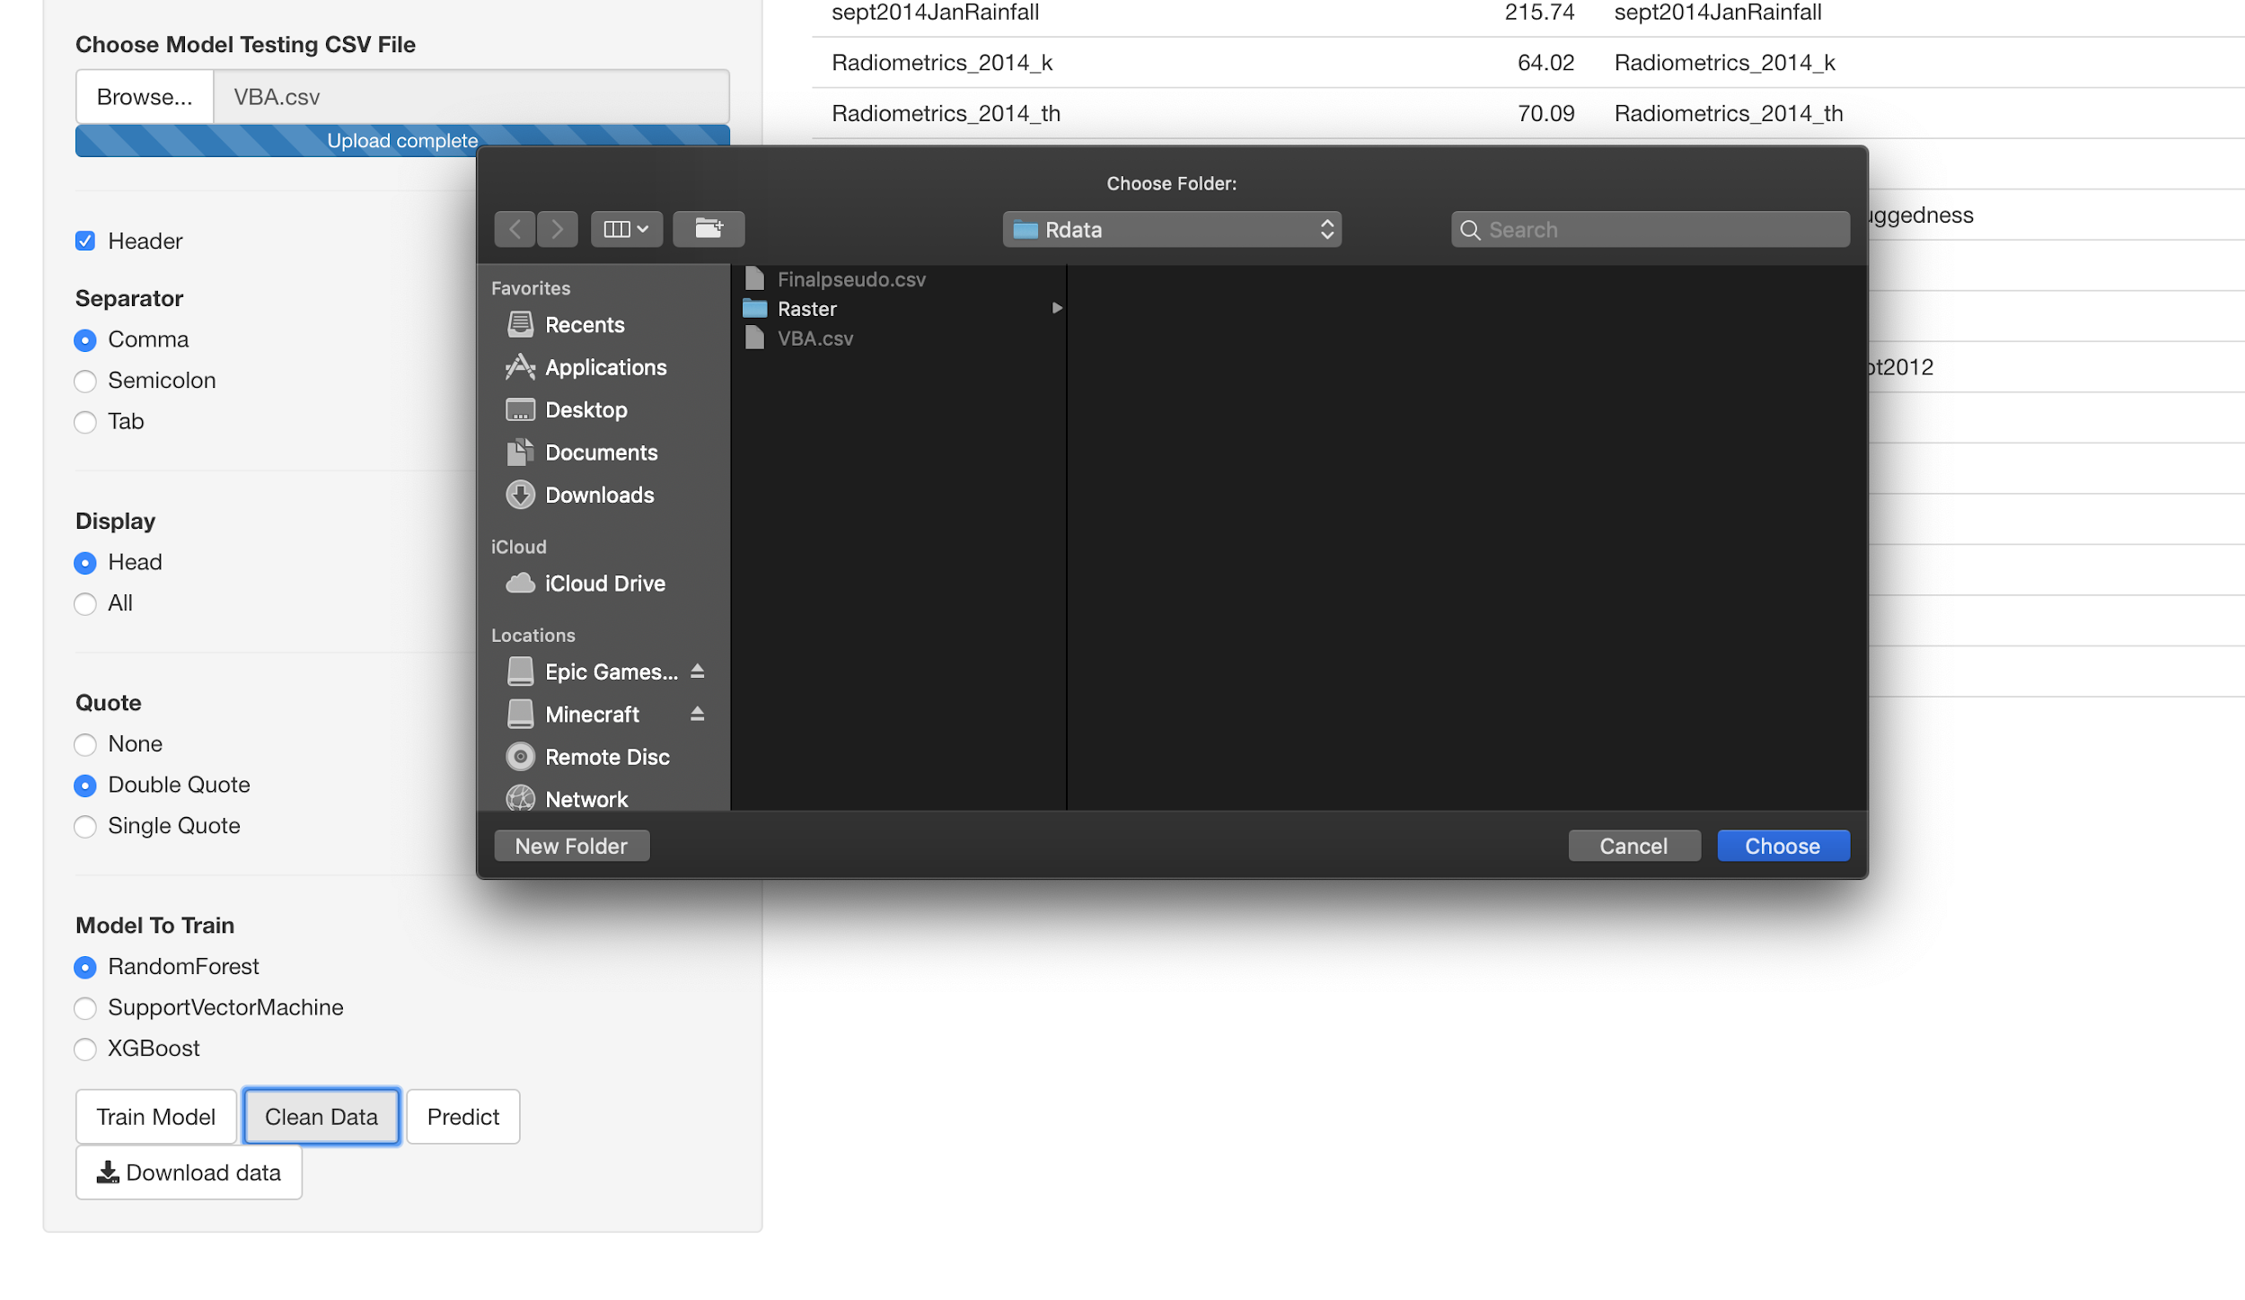

This window asks you to show it where the raster files directory is.

The raster files is in “FIT3164S2” -> “Rdata” -> “Raster”

(OR Follow the steps shown below)

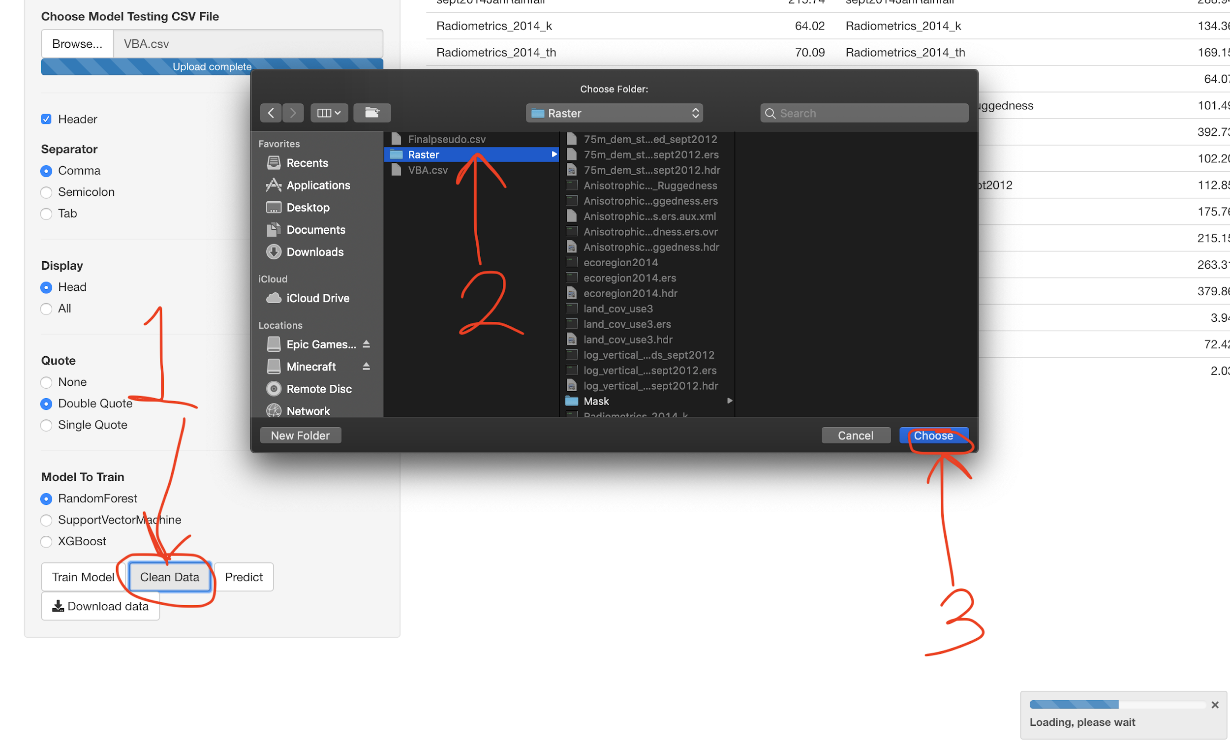

Once you have finished this step, it will take a while for the system to clean the data

Because it is reading all the raster files and shape files and extracting the information from them to the VBA data and also cleaning and turning the format of the data into something that can be used to generate models.

Once it has finished, another table will show at the top with the first 6 rows of data.

(Not showing more because the more rows of data it shows the slower the system runs)

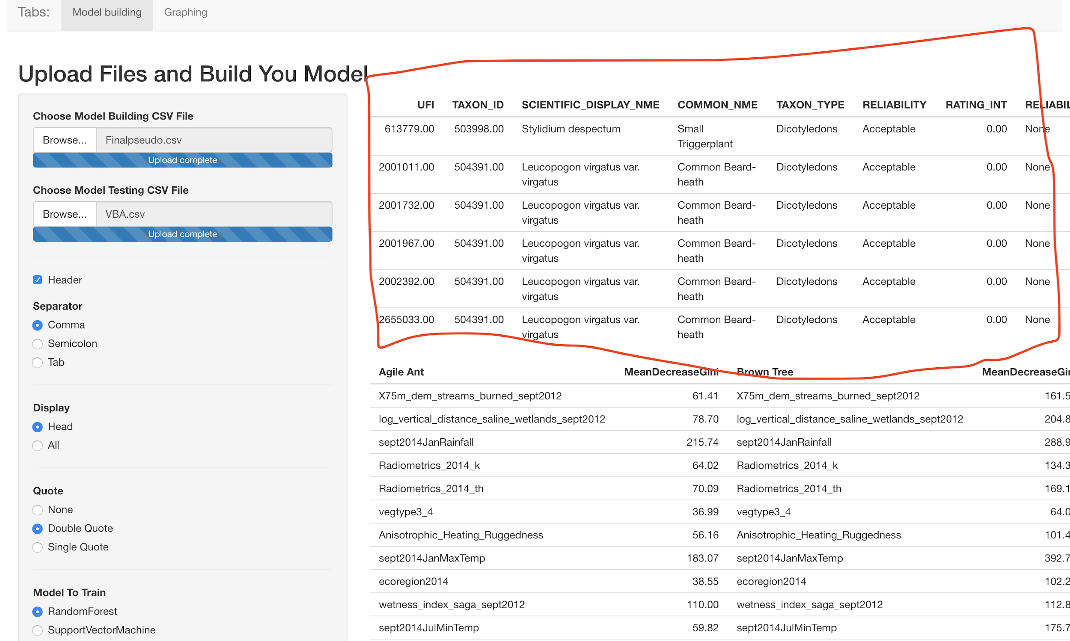

You can scroll to the right to see more:

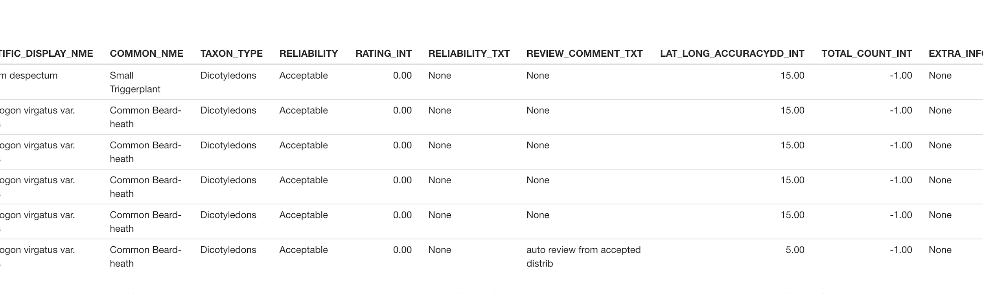

Otherwise, we are now done will data cleaning and the only steps left will be to predict and draw our graphs

----------------------------------------------------------------------------------------------------------------

Predicting

----------------------------------------------------------------------------------------------------------------

Scroll back to the bottom and press the Predict button

After a few seconds

A new table should be shown in between the two other tables:

(Red circle indicates the button)

(Red rectangle indicates the predicted value by the model)

(Blue rectangle indicates the VBA data)

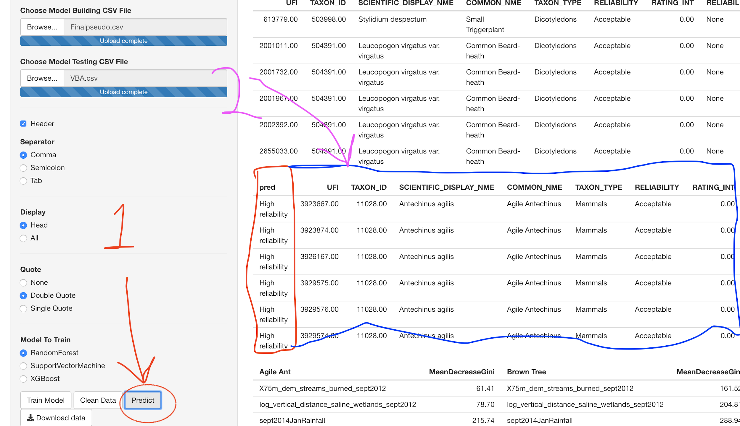

Now we have predicted the reliability of each of the rows in the VBA data.

We can now, use it to plot a graph and physically see which points have been predicted by our model to be reliable and which are unreliable

----------------------------------------------------------------------------------------------------------------

Graphing

----------------------------------------------------------------------------------------------------------------

Navigate to the top

On the top left you should see a Graphing tab:

Select the graphing tab:

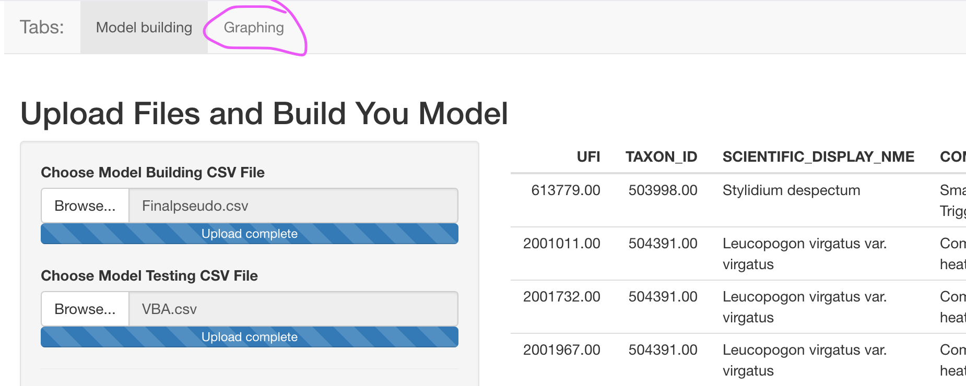

This page should show up

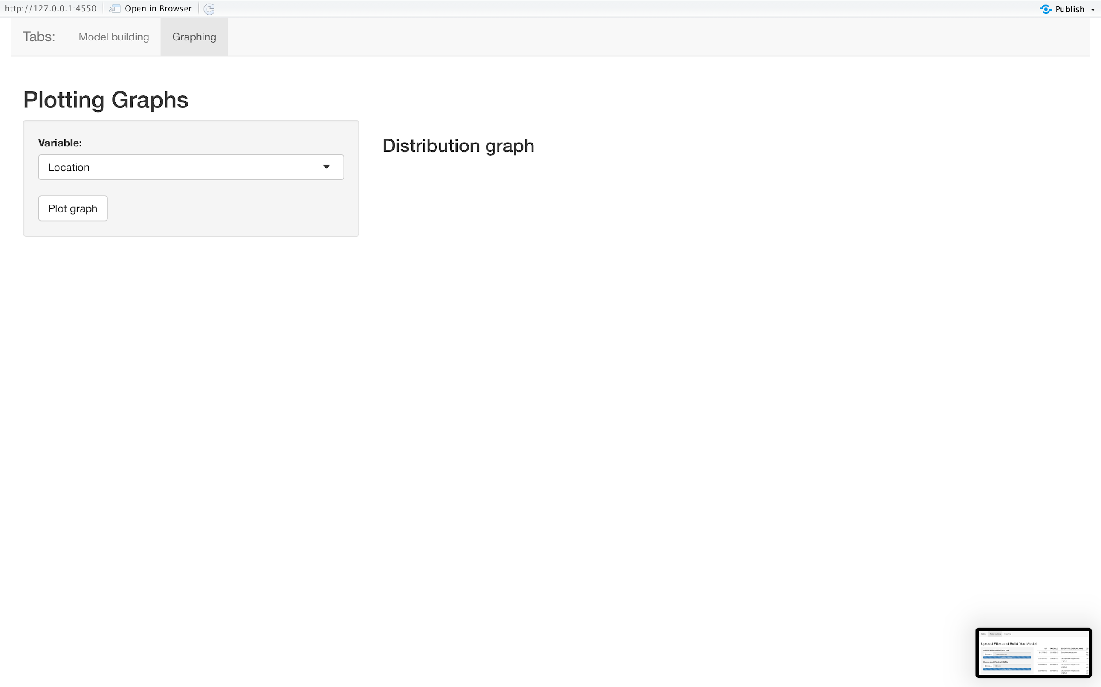

Press the Plot graph button to plot the Graph

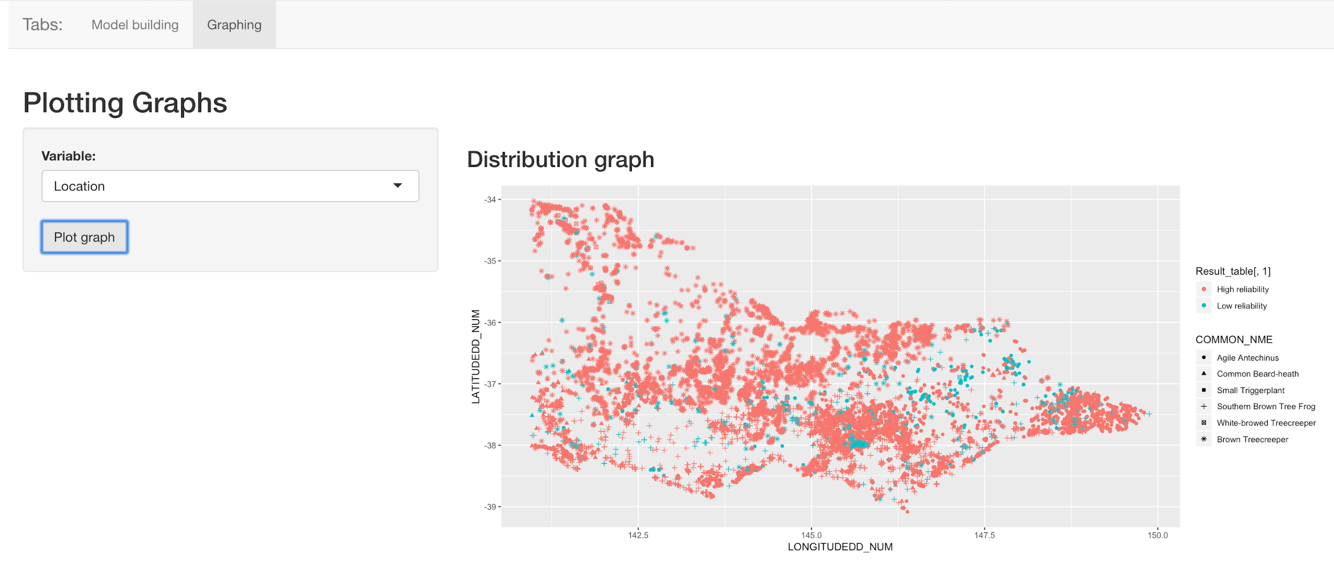

Now this shows which points were predicted as high reliability and which are low reliability.

This is not too useful as it does not allow interaction.

This graph is merely for the physical observation of the user.

The system also provide a Download function which the user can use to download the predicted data and do some further research for their own.

Navigate back to the Model Building tab at the top left

----------------------------------------------------------------------------------------------------------------

Downloading Data

----------------------------------------------------------------------------------------------------------------

Once you are back at the Model Building tab, on the left hand side, A download Data button should be there at the bottom:

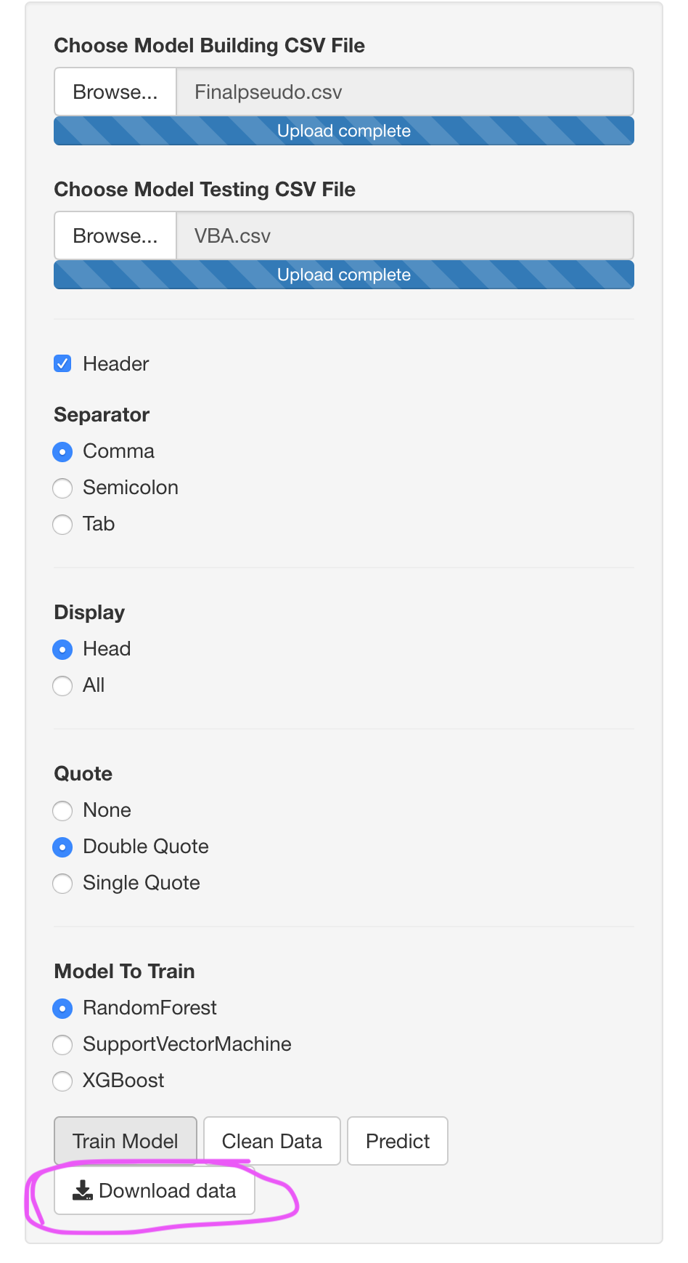

Press the Download Data Button and a window will pop up:

(It will ask for a directory where the user would like the files to be save)

Select the directory you want to save the file to: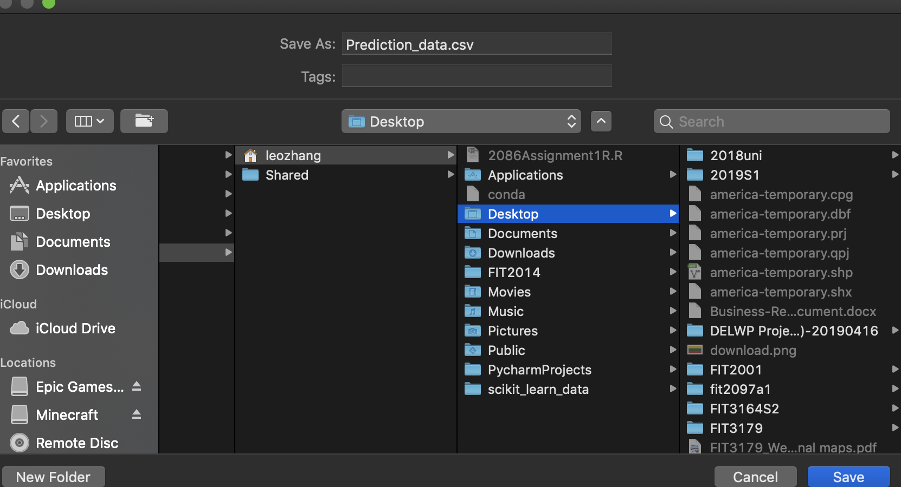

Press save, and the file should be at the target location and is ready to use for more exploration.

----------------------------------------------------------------------------------------------------------------

----------------------------------------------------------------------------------------------------------------

Extra Information

----------------------------------------------------------------------------------------------------------------

The steps to predicting data:

Upload both CSVs

|

|

Press Clean Data button

|

|

Choose Model type

|

|

Press Train Model button

|

|

Press Predict

|

|

Done

(After the Clean Data button has been pressed, it should not be pressed again)

Training other models do not need to clean data again

Simply choose another model type and then Press the Train Model Button to get New Models

Remember: Predict only works when a Model has been trained and the Data has been cleaned

----------------------------------------------------------------------------------------------------------------

Thanks for reading.